Abstract

This study is mainly discusses about testing of two different computer units using a micro benchmark program to inspect their performance. Every unit was tested thrice to have better outlook of their execution. The behavior and specs of every unit is illustated in a table and graph.

Introduction

A microbenchmark is either a program or routine to calculate
and evaluate the performance of a particular part or task and is also used to evaluate basic and well-defined quantities
such as time taken, rate of operations, bandwidth, or latency.
Microbenchmarks are usually concerned with checking particular program subroutines or lower-level
hardware elements, such as the CPU, over a limited period of time as stated in Encyclopedia of Big Data Technologies.

According to Science Direct it says that Microbenchmarks may have a set of attributes that
are static and dynamic in a microbenchmark generation process.
Microbenchmarks that fulfill a series of static properties may be generated directly also because
static properties do not depend on the setting in which the microbenchmark is implemented.
This types of properties include dissemination of instructions, footprint of code and
data, distance of dependency, branch patterns, and patterns of access to the data.
In contrast, it is a complex task to
generate microbenchmarks with a given collection of dynamic properties.
The static microbenchmark properties as well as the design on which
the microbenchmark is run are specifically influenced by the dynamic properties.
Dynamic properties examples include per-cycle instructions,
memory hit/miss ratios, power, or temperature.

MICRO BENCHMARKING PROGRAM
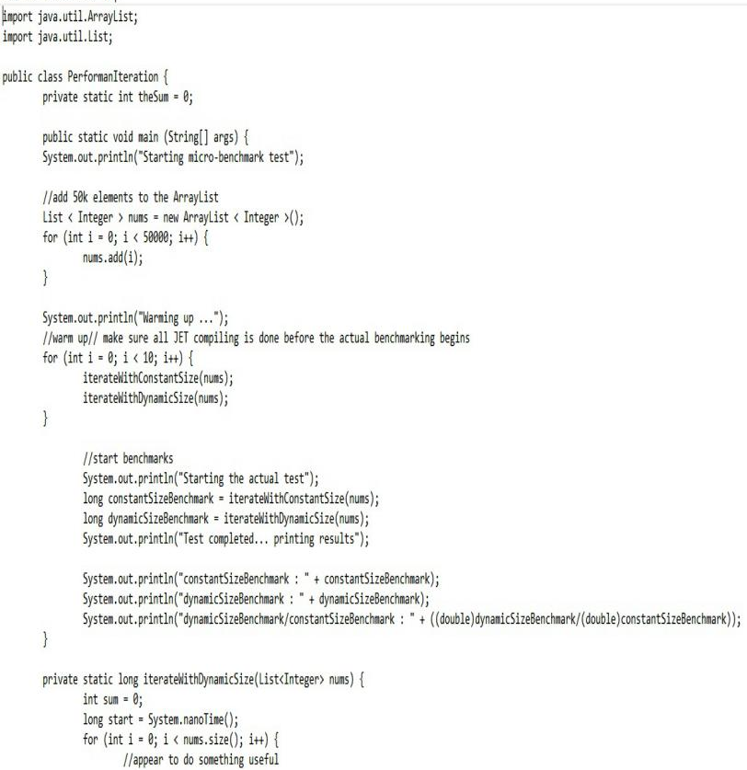

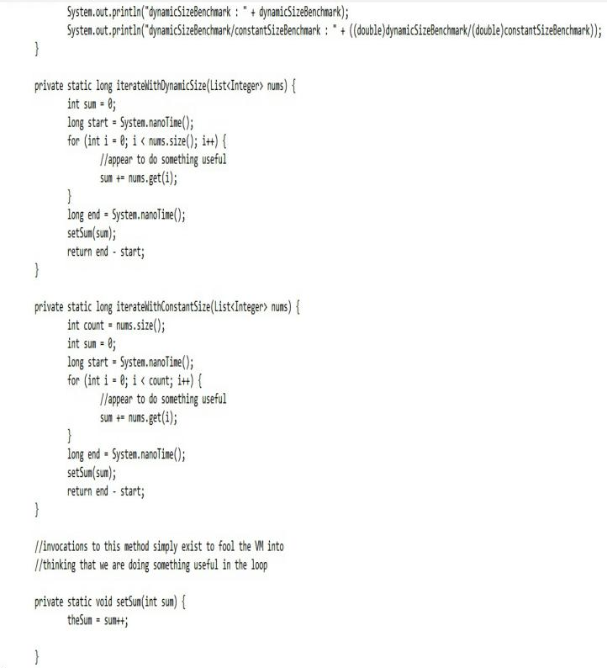

This program is mainly used because oft its purpose to run a program, containing the constant size and dynamic size of the benchmark in a particular unit it is also called the Performance Iteration.

COMPUTER UNITS
Table 1
 | ASUS | Hi-Fi
System Name | LAPTOP-M7B7LCQ8 | USER-PC
System Manufacturer | ASUSTek COMPUTER INC. | BIOSTAR Group
System Model | VivoBook 14_ASUS Laptop X407UAR | Hi-Fi A70U3P
System Type | x64-based PC | x64-based PC
Processor | Intel® Core(TM)i37020U CPU @ 2.30GHz | AMD A-45300 APU 3,40 GHz
RAM | 4.00 GB | 4.00 GB
OS Name | Windows 10 Home single Language | Windows 7 Ultimate

The Computer Units used in this study is ASUS and Hi-Fi with the same level of RAM (4.00 GB) and System Type(x64) with different brand of processor namely Intel for ASUS and AMD for Hi-Fi also different Windows Edition, ASUS has the Windows 10 and the other one has Windows 7.

BENCHMARKING

Table 2. Performance Iteration of ASUS
Test No. | constantSize Benchmark | dynamicSize Benchmark | constantSize  Benchmark/  dynamicSize  Benchmark
1 | 824100 | 891700 | 1.0820288799902924
2 | 598300 | 659900 | 1.1029583820825672
3 | 293800 | 299900 | 1.207624234172907

Table 2.1 Performance Iteration of Hi-Fi
Test No. | constantSize Benchmark | dynamicSize Benchmark | constantSize  Benchmark/  DynamicSize  Benchmark
1 | 471311 | 556702 | 1.1811776088400228
2 | 464112 | 523210 | 1.1521607004439434
3 | 474932 | 524115 | 1.1035579830375717

As seen in the table above, the performance iteration from the two different computer units tested thrice. The PI (Performance Iteration) in ASUS it started from 1.08, then to 1.10 then lastly 1.20. On the other hand from Hi-Fi it started from 1.18 to 1.15l then lastly, 1.10.

The Performance Iteration of ASUS is better than the Hi-Fi for the reason that its constantSize Benchmark/ DynamicSize Benchmark of the model ASUS is lower than the Hi-Fi model. It is evident on the First to the Last trial of both computer units.

RESULTS AND DISCUSSION

The performance iteration has three type of results namely the ConstantSize Benchmark, DynamicSize Benchmark and

The ConstantSizeBenchmark(CSB) of the both units differ starting from ASUS, it began from a high amount of number then from trial two to three the amount started to shrink. In addition to this, The CSB of the Hi-Fi unit created only small amount of change.

The DynamicSize Benchmark of the model ASUS has the same performance in its CSB because the amount was descending and also in the model Hi-Fi, its performance created only a small dissimilarity on its number .

Lastly, the ConstantSize Benchmark/ DynamicSize Benchmark of ASUS model the number slightly moves from high then the number decrease then increases again, while in the Hi-Fi model, the numbers decreases from trial to trial.

TABLE 3

TABLE 3.1

CONCLUSION

The irrefutable fact that has been conclude in this study that between the two computer units, with the help of micro benchmark program assist us to visually distinguish that ASUS model does better performance than the other unit.

